INTERNATIONAL SCIENTIFIC CONGRESS-2002

“FUNDAMENTAL PROBLEMS OF NATURAL SCIENCE AND ENGINEERING”

is held on July 8 – 13 in Saint-Petersburg at Institute of International Education’s Programs (IIEP) – Grazhdansky prosp , 28
Transport: Metro “Polytechnicheskaya” or “Lesnaya”, than by trolley bus 31 or route’s taxies 9, 48, 95 , 160. The best is the 10 minutes walk, see the chart below.
The reception of participants is carried out by Service of Reception of Military Academy of Communication (M.Ac.Com.)
(Tichoretsky pr. 3, Metro “Polytechnicheskaya”):
July 6 – at 10 ^{h}. to 22^{h}
July 7 – at 09 ^{h} , day and night, to 9 ^{h} July 8.
Registration of the participants of Congress 2002 at Institute of International Education’s Programs (IIEP)
July 7 — at 10 ^{h} to 22 ^{h}
July 8 — at 08 ^{h} to 20 ^{h} ,
in the rest time — in Organizing Committee in IIEP , auditorium 228.

Sessions of Congress 2002 will be held in conference-hall and auditoriums
328 (3-id floor), 432 (4-th floor), 734 (7-th floor).

The books and other materials of the conferences and congresses — in auditorium 330 (3-id floor).

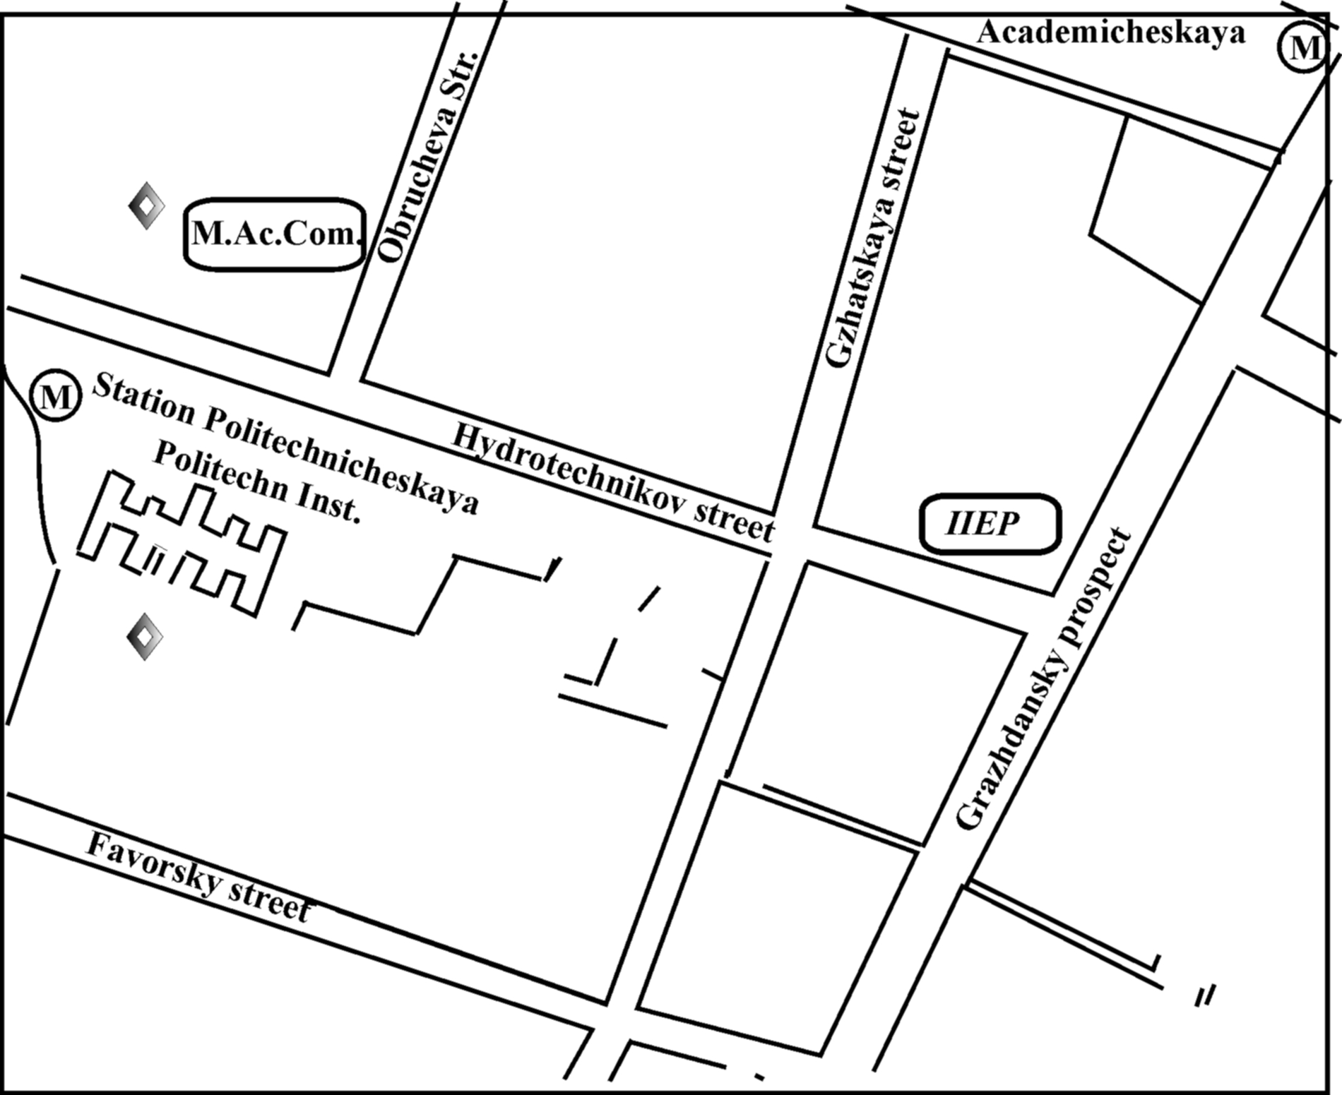
PROGRAM
OF CONGRESS – 2002:
“FUNDAMENTAL PROBLEMS OF NATURAL SCIENCES AND INGINEERING

July 8, Monday, 2002
10-00 – 13-30
PLENARY SESSION
Conference–hall

ETHER AND ETHERODYNAMICS (П – 8)
Co-chairmen: Klushin Ya.G., Smirnov A.P. Nassikas A.
1. Mishin A.M..  2. Proossov P.D.  3. Rezanov I.A.  4. Ushakovskaya E.D.  5. Peschevitskij B.I.  6. Dvoeglazov V.V. | 7 Reboledo M.R.  8. Simakov A.S.  9. Nassikas A.A.  10. Bolstein A.  11. Petric S.

11-30 – 12-00 coffee-break
13-30 – 15-00 dinner

Evening sessions 15-00 – 18-30
______________________________________________________________________

2 section – conference-hall (С – 2, 8)

ORGANIZATION’S LEVELS, STRUCTURE’S ELEMENTS
OF NATURAL SCIENCE’S OBJECTS
Co-chairmen: Smirnov A.P., Babin W., Kanarev Ph.M.
1. Bondarenko O.Ya.  2. Kanarev F.M.  3. Syromyatnikov A.G.  4. Kanarev F.M.  5. Shpacov P.D.  6. Leonov B.P. | 7. Bychkov V.A., Bychkov V.A.,.Timofeev I.B.  8. Popov D.I.  9. Bondarenko O.Ya.  10. Ratnikov B.P.

16-30 – 17-00 coffee-break

4 section – auditorium 734 (C – 4, 8)

ETHERODYNAMICS, ELECTRODYNAMICS, GRAVITATION
Co-chairmen: Klushin Ja.G., Vereshchagin I.A.
1. Asanbaeva D.A..  2. Fominskij L.P.  3. Ustimenko E.F..  4. Butusov K.P..  5. Butusov K.P..  6. Bondarenko O.Ya. | 7.Lebedev V.A.  8. Lebedev V.A...  9. Veretshagin I.A.  10. Rajkov A.A.  11. Mishin A.M..  12. Cherepanov O.Ya.

16-30 -- 17-00 coffee-break
July 8, Monday, 2002
Evening sessions 15-00 – 18-30

6 section – auditorium 432 (C – 6, 8)

PHYSICAL BASIS OF INFORMATION SYSTEMS AND COMMUNICATION
Co-chairmen: Likhachev A.M., Ignatiev B.M.
1. Dubro V.G.  2. Proossov P.D..  3. Proossov P.D., Коchetkov V.A.  4. Belyaev M.I. | 5. Bondarenko O.Ya.  6. Ruzhanskij V.I.,Ruzhanskij M.V.  7. Boldyreva L.B, Sotina N.B.  8. Borisova N.N.

16-30 – 17-00 coffee-break

July 8, Monday, 2002
Evening sessions 15-00 – 18-30

3 section — auditorium 328 (C – 3, 8)

TIME AND SPACE IN THE REAL WORLD
Со-chairmen: Cherepanov O.A., Dvoyeglazov V.V.
1.Dubro V.G.  2. Оlejnik V.P.  3. Cherepanov O.V.  4. Коtov К.М.  5. Кuznetsov А.А.  6. Ivanchenko G.E..  7. Fominskij L.P. | 8. Nikolenko К.L.  9. Losovskij М.G.

16-зо – 17-оо coffee-break

July 9,Tuesday, 2002
10-00 – 13-30

PLENARY SESSION
Conference-hall
SYNTHESIS OF SCIENCES AND ELECTRODYNAMICS
Co-chairmen: Klushin Ya.G., Smirnov A.P., Dvoyeglazov V.V.
1. Babin Walter  2. Post Evert Jan.  3. Каdyrov С.К.  4. Каnаrеv F.М.  5. Кеilмаn Yu.N.  6. Кlushin Ya.G. | 7.Belyaev М.I.  8. Blednov V.A.  9. Spenser Domina Eberle  10. Curry Adam  11. Моuafak Ichola Aimi

11-30 – 12-00 coffee-break
July 9,Tuesday, 2002
10-00 — 13-30
6 section – auditorium 734 (C – 6, 9c)

PHYSICAL BASIS OF INFORMATION SYSTEMS AND COMMUNICATION
Co-chairmen: Lichachev A.M., Ignatiev B.M.
1. Аverianov E.G.  2. Аladinskij V.A., Моtkov V.I.,  Simonov A.N., Saukov А.М.  3. Belyakov E.V.  4. Beletskij A.I.,Ryzhov M.V., Sosunov B.V., Токаrev S.M..  5. Beletskij A.I.,Ryzhov M.V., Sosunov B.V., Токаrev S.M.  6. Bobrovskij V.I.  7. Bobrovskij V.I., Davidov A.V.  8. Bobrovskij V.I., Timoshin I.V. | 9. Bondarenko C.A.  10. Viharev E.V.  11. Gotnoga S.V.  12. Dobrovolskij S.A.  13.Dovgij A.V..  14. Zhirov V.A.  15. Каlyuка V.I.  16. КеrkoV.A, Poluyan P.М.  17. Коmashinskij V.I., Portnov V.V.

11-30 – 12-00 coffee-break

July 9,Tuesday, 2002
10-00 — 13-30
1 section — auditorium 338 (C – 1, 9c)
FUNDAMENTAL APPROACHES TO COGNITION OF REALITY
Co-chairmen: Prokhortsev I.V., Khromov L.I.
1. Khromov L.I. .  2. Ushakovskaya E.D.  3. Borisova N.P. | 4. Borisova N.N.  5. Prokhortsev I.V.,

11-30 – 12-00 coffee-break

13-30 — 15-00 — dinnerr
July 9,Tuesday, 2002
Evening Session 15-00 – 18-30

2 section – conference-hall (C –2, 9)
ORGANIZATION’S LEVELS, STRUCTURE’S ELEMENTS
OF NATURAL SCIENCE’S OBJECTS
Со-chairmen: Smirnov A.P., Keilman Yu.N., Peshchevitskij B.I.
1. Dubro V.G.  2. Lyalin A.V.  3. Ivanov B.P.  4. Shabelnikov A.B.  5. Shlenov A.G.  6. Shlenov A.G.. | 7. Proossov P.D..  8. Frolov V.A.  9. Frolov V.A..  10. Frolov V.A..  11. Rylkov V.P.

16-зо – 17-оо – coffee- break

July 9,Tuesday, 2002

4 section – auditorium 734 (C – 4, 9)

ETHERODYNAMICS, ELECTRODYNAMICS AND GRAVITATION
Со-chairmen: Klushin Ya.G., Ustimenko Yu F.
1. Lebedev V.A..  2. Коrotkov B.A..  3. Korotkov B.A.  4. Korotkov B.A.  5. Ageev Yu.M. | 6. Proossov P.D.  7 Post P.D.  8. Boldyreva L.B., Sotina N.B.  9. Pochtarev A.P.

16-30 – 17-00 coffee-break

July 9,Tuesday, 2002
Evening session
15-00 — 18-30
3 section – auditorium 328 (C – 3, 9)
TIME AND SPACE IN REAL WORLD
Со-chairmen: Cherepanov O.A., Bondarenko O.Ya.
1. Vereshchagin I.A.  2. Kuferstein M.Z.  3. Kuferstein M.Z. | 4. Fedorovskiy G.D.  5. Guzevich S.N.  6. Cherepanov O.A.

16-30 – 17-00 coffee-break

July 9,Tuesday, 2002
Evening session
15-00 — 18-30

POSTER SESSION –auditorium 432 (ПС – 9)

16-30 – 17-00 coffee-break

July 10 Wednesday, 2002

10-00 – 13-30

PLENARY SESSION
Conference-hall

PRINCIPLES AND LAWS (П – 10)
Co-chairmen: Smirnov A.P., Sano Ch., Dvoyeglazov V.V.
1. Baurov Yu.A., Shpital’naya A.A.,  Efimov A.A., Zakoldaev Yu.A.  2. Myasnikov V.M.  3. Smirnov A.P.  4. Sano Ch. | 5. Dmitrievskiy O.D., Sall S.A.  6. Smirnov E.Ya.  7. Frolov V.A.  8. Popov V.G.  9. Nassikas A.A.

11-30 – 12-00 coffee-break

13-30 – 15-00 dinner

July 10 Wednesday, 2002
Evening session 15-00 – 19-00
________________________________________________________________________

CATHARSIS CONFERENCE
Conference-hall
“METAPHYSICS OF REALITY”

July 11, Thursday 2000

10-00 –13-30

PLENARY SESSION
Conference-hall

FUNDAMENTAL PROBLEMS OF NATURAL SCIENCE (П – 11)
Co-chairmen: Smirnov A.P., Bolstein A., Kanarev Ph. M.
1. Petrov A.S.  2.Stekachev V.I.  3.Malov I.F., Frolov V.A.  4.Suhorukov G.I, Suhorukov E.G., Suhorukov R.G.  5.Stolmar A. | 6.Ivanov B.P.  7.Buren V.M.  8.Vasilev A.I.  9. Spiliotis X.D.  10. Lozdvskij M.G.

11-30 –12-00 coffee-break

July 11, Thursday 2000
10-00 — 13-30

Section 6, auditorium 734 (C – 6, 11c)
PHYSICAL BASIS OF INFORMATION SYSTEM AND COMMUNICATION
Со-chairmen: Lichachev A.M., Ignatiev B.M.
1.Коrotkov V.F., Кudryavzev А.М., Оstrovskij Yu.M., Getmanzev А.А.  2. Kudryavzev A.M., Hazov V.B., Plotnikov A.M., Udalzev N.P., Petrov I.B.  3. Kuznecov V.E., Belikov E.V.  4. Kuznecov V.E., Grebnev D.V.  5. Kuznecov V.E., Pominchuk O.V.  6. Lepenyshev A.N., Chihachev A.V.  7. Lihachev A.M., Кuznezov V.E., Dvoryakov V.V.  8. Маhetov А.B.. | 9. Маhetov А.B., Rogetdinov О.Z.  10. Моlokovich I.A.  11. Моlotkov Yu.A.  12. Моtkov V.I., Saukov A.M.  13. Naukovich А.N., Dovgij AA.V.  14. Nesterov I.A.  15. Оvchinnikova N.V.  16. Pаrаschuk I.B.

11-30 – 12-00 coffee-break

13-30 – 15-00 dinner

July 11, Thursday 2000
Evening session 15-00 – 18-30
_______________________________________________________________________

Section 1, conference-hall (C – 1, 11)
FUNDAMENTAL APPROACHES TO COGNITION OF REALITY
Со-chairmen: Smirnov A.P., Peschevitskij B.I., Fominskij L.P.
1. Bondarenko O.Ya.  2. Ignatiev M.B.  3. Dudkin K.I.  4. Пеtrash V.V.  5. Ivanov B.P. | 6. Trofimov А.М.  7. Frolov V.А.  8. Коndrakov G.V.  9. Pachomova G.V.

16-30 – 17-00 coffee-break
July 11, Thursday 2000
Evening session 15-00 – 18-30

Section 5, auditorium734 (C – 5, 11)

EARTH’S SPHERES AND THEIR INTERACTION. PROBLEMS OF CLIMATE
Со-chairmen: Olejnikov A.N., Rudnik V.A.
1. Gornyj V.I., Tumanov V.L., Dertev A.K.  2. Bereslavskij E.N.  3. Bereslavskij E.N., Solovjova T.V.  4. Anohin V.M., Оdesskij I.М.  5. Petrov T.G.  6. Perevedenzev Yu., P., Vereschagin М.А., Shantelinskij К.М.  7. Кiryukov V.V., Кusch О.А., Кrylov S.O. | 8. Zakoldaev Yu.A., Маrinich Т.L.,  Shpitalnaya А.А., Еfimov А.А.,  Bogacheva N.D.  9. Petrov К.М.  10. Кuderina L.D.  11. Кrivoshej M.I.  12. Pijanov V.I.  13. Аbramyan V.K.
16-30 – 17-00 coffee-break

July 11, Thursday 2000
Evening session 15-00 – 18-30
Section 7, auditorium 328 (C – 7, 11)
POWERS, TECHNIQUE, TECHNOLOGY OF THIRD MILLENIUM
Со-chairmen: Аndreev E.I., Potapov Yu.S., Katkov М.S.
1. Denisenko P.I., Panteleev A.V.  2. Моtоvilin G.V.  3. Chernoplekov N.A., Chubraeva L.I.  4. Furmakov E.F.  5. Sall S.A., Smirnov A.P. | 6. Аndreev E.I., Smirnov A.P..  7. Zukanov B.I.  8. Каtkov M.S., Skalon A.I.  9. Zhelezhyij V.B.

16-30 – 17-00 coffee-break

July 11, Thursday 2000
Evening session 15-00 – 18-30

1 section, audutorium 432 (C – 1, 11c)
FUNDAMENTAL PROBLEMS OF NATURAL SCIENCE
Со-chairmen: Кlyushin Ya.G., Оlejnik V.L.
1. Zhuk N.A.(7 papers)  2. Каtz V.E. | 3. Snagoschenko A.V., Bondarenko S.V.  4. Маlyshev Yu.М.

16-зо – 17-оо – coffee-break

July 12, Friday 2002
10-00 – 13-30

PLENARY SESSION
Conference-hall

TECHNIQUE AND TECHNOLOGY
Co-chairmen: Smirnov A.P., Mac-Cabe F., Potapov Yu.S.
1. МcCabe F.J.  2. Оlejnik V.P., Arepjev Yu.D.  3. Feng Cao Jun | 4. Conte E..  5. Stolmar A.  6. Potapov Yu.S., Fominskij L.D., Potapov S.Yu.

11-30 – 12-00 coffee-break

July 12, Friday 2002
10-00 – 13-30

Section 6, auditorium 734 (C – 6, 12c)

PHYSICAL BASIS OF INFORMATION SYSTEMS AND COMMUNICATION
Со-chairmen: Lihachev A.M., Ignatiev B.M.
1. Naukovich А.N., Dovgij A.V.  2. Nesterov I.A.  3. Оvchinnikova N.V.  4. Paraschuk I.B.  5. Privalov A.A.  6. Privalov А. А.  7. Rozhetdinov O.Z.  8. Rozhetdinov O.Z.  9. Romanov A.G. | 10. Santov I.A., Belausov E.N.  11. Saukov A.M., Simonov A.N.  12. Simonov A.N.  13. Smirnov D.I.  14. Udalzev N.P., Hazov V.B.,  Plotnikov A.M., Petrov I.B.  15. Hillko V.O.  16. Hohlenko Yu. L., Chelyshev V.D.,  Yakimovec V.V.  17. Chihachev A.V.

11-30 – 12-00 coffee-break

13-30 – 15-00 dinner

July 12, Friday 2002
Evening sessions, 15-00 – 18-30
_______________________________________________________________________

Section 1, Conference-hall (C – 1, 12)

FUNDAMENTAL APPROACHES TO COGNITION OF REALITY

Со-chairmen: Smirnov A.P., Kadyrov S., Belyaev M.I.
1. Ivanov B.P.  2. Ivanov B.P.  3. Dubro V.G.  4. Vasilzov E.A | 5. Коrennaya A.B.  6.Sokolov I.I., Smirnov A.Ju., Stepanov V.V.  7. Кiselev S.A., Komarovskih K.F., Heifez L.I.  8. Frolov V.A.

16-зо – 17-оо –coffee-break

July 12, Friday 2002
Evening sessions, 15-00 – 18-30
Section 5, auditorium 734 (C – 5, 12)

EARTH’S SPHERES AND THEIR INTERACTION. PROBLEMS OF CLIMATE
Со-chairman: Olejnikov A.N., Rudnik V.A.
1. Bondarenko O.Ya.  2. Smirnov E.Ya.  3. Roschupkina T.M.  4. Vasiljeva G.Ya.., Nesterov M.M.,Chernyh Yu. V.  5.Vasilieva G.Ya.  6. Маlov I.F., Frolov V.A.  7. Butusov K.P.  8. Butusov K.P. | 9. Butusov K.P.  10. Frolov V.A.  11. Кrivoshej М.А.  12. Кrivoshej М.А.  13. Аntonov A.E.  14. Моnahov L. Yu.  15. Shults jr S.S.

16-30 – 17-00 coffee-break

July 12, Friday 2002
Evening sessions, 15-00 – 18-30
Section 1, auditorium 432 (C – 1, 12c)

CONSCIOUSNESS, WORLD OUTLOOK AND SCIENCE

Сопредседатели: Klyushin Ya.G., Oleynik V.P.
1. Khromov L.I.  2. Borisova N.P.  3. Borisova N.N. | 4. Ushakovskaya E.D.  5. Prpkhortsev I.V.

July 12, Friday 2002
Evening sessions, 15-00 – 18-30

THE ROUND TABLES, auditorium 328

DISSCUSSING PROBLEMS OF MODERN NATURAL SCIENCE

July 13, Saturday 2002
10-00 – 14-00

PLENARY SESSION
Conference-hall

PARADIGMS IN SCIENCE AND THE PRESENT

Discussion
Co-chairmen: Smirnov A.P., Klushin Ya.G., Sano Ch., Nassikas A.A., Dvoeglazov V.V.

12-00 – 12-30 coffee-break

13-30 — 15-00 — dinnerr

July 13, Saturday 2002
Evening sessions, 15-00 – 18-30

PLENARY SESSION
Conference-hall

THE DISCUSSION OF CONGRESS WORK

CLOSING OF CONGRESS-2002
Для заметок For Notes

